**Twin Oaks HOA July**

6:03pm call to order

Meeting Minutes Review from June Meeting – Motion for approval from Chuck H. – seconded by Bill F., and carried by all

**Office Elections**

Bill F. made a motion for Chuck H. as president and Blaine K. as VP – Carried

President: Chuck Haberman

Vice President: Blaine Kinsler

Secretary: Chuck McKay

Treasurer: Shondra Zaborowski

Member at Large: Bill Fraley

Chuck H. motioned to the member allocations above – Seconded by Shondra and carried by the rest of the board

**Financial Review**

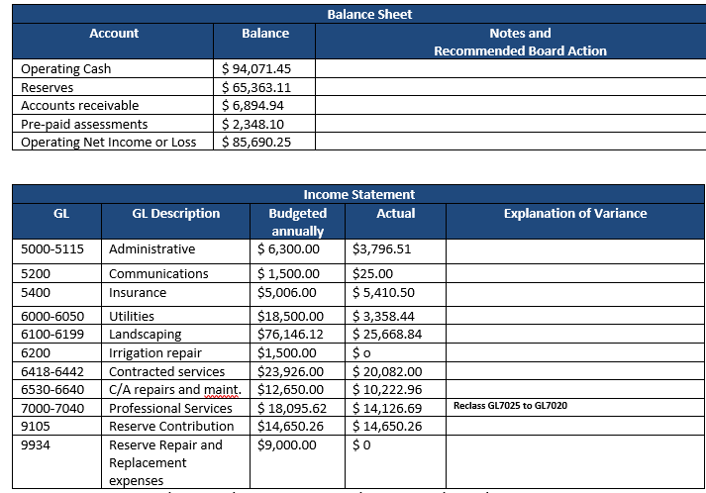

**Maintenance**

Pond Overview

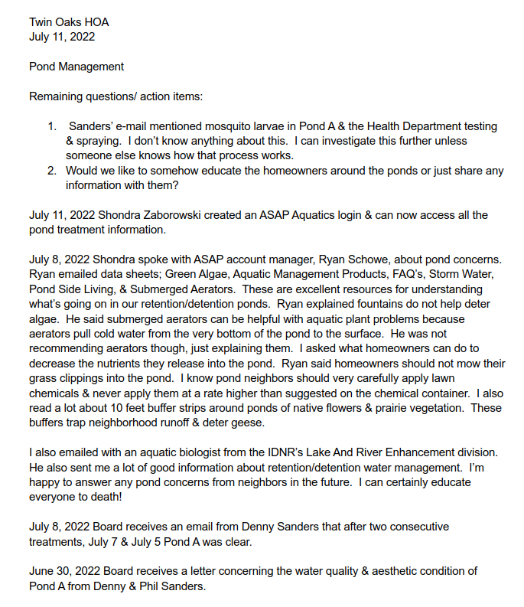

1. A pond education summary will be put together and uploaded to Town Square and the Twin Oaks website for neighborhood education
2. Rina – Lot 37 on Stroup Drive (Pond A)
   1. The pond was surrounded by vegetation & all algae had floated to the top in the early June timeframe
   2. Vegetation is overgrown not allowing neighbors to get close to the pond edge – a large amount of vegetation has grown over the last 2 years on Pond A
   3. An Aerator fountain could help with cleaning the pond and the extreme vegetation did not help with the appearance or the cleanliness of it
   4. The recorded easement for access to pond A is on the edge of lot 184
   5. Pond A has been treated 8 times this year by ASAP Aquatics – it was too wet in late May for them to access the pond
   6. The ponds in the neighborhood are functional for stormwater retention and detention
   7. Can a new or other vendor be brought in to help with cutting down and disposing of the vegetation around the edges of the pond?
      1. The board will get quotes from Landscaping & Aquatic companies to cut down and dispose of overgrown vegetation around Pond A
3. Anything within the water itself has to be treated by an aquatics company
4. What can the DNR do? (Possibly get an aquatic biologist to come out and discuss options) – Shondra can reach out to DNR
5. BAM would be able to go to down to the edge of the ponds to cut vegetation & clean the drainage & banks
   1. BAM can have it written in their contracts that they can go as close to the edge of the pond water as possible
6. Can a coordination occur between ASAP & BAM take place to make sure everyone is in alignment of what needs to happen?
   * 1. A meeting will be set with BAM & ASAP for alignment on a go forward plan
7. Cleaning out drain lines & rep rap from the pipes to the ponds (Cleaning out the inside of the pipes of trash, weeds, debris, etc. and replace the rep rap) ($850 per pipe)
   1. The only pond ready to have this done is the pond by the pool
   2. Chuck H. moved to have the rep rap done by BAM on the pond by the pool – Blaine seconded – Carried by all
8. Pond A will require a meeting between Chuck H. BAM & ASAP Aquatics to communicate clearly what needs to happen
9. We can prepare for a larger financial contribution to these items in the budget for 2023

**Irrigation Backflow**

Two backflows were cut out and stolen

Quote from BAM to replace the backflows we as well as installing concrete pads and strong boxes with locking mechanisms

Money to pay for this can come from budgeted Irrigation repairs, and the rest would come from our reserve savings – other tasks may have to be put on the backburning to offset

Chuck M. moved to carry out the repairs and installations – Chuck H. seconded and all carried

**Street Light Replacement**

There was a witness of the damage being done to the pole which was caught on a ring camera

We will put the witness in touch with Olga if there is still a video available

**New Business**

1. Reimbursement to Drake for the expense on the HOA website $300 – Chuck H. motioned to reimbursed, Bill seconded and carried by all
2. An ask to change out all street lights that are halogen to LED, which will use less energy (27 lights would be around ~$2,565)
   1. Olga will ask the vendor for what the annual savings would be
3. Should fish be added to the ponds?  Not at this time, just get quotes to treat the ponds with chemicals.
4. A quote will be acquired to add aerating fountains to the ponds
5. Need to seriously look into seal coating the walking paths & pool bottom painting for next year

Meeting Adjourned @ 7:26pm

Next Meeting will be Monday, August 8th @ 6pm EST